Assembly and
Operation of the


FM Broadcast Receiver Module
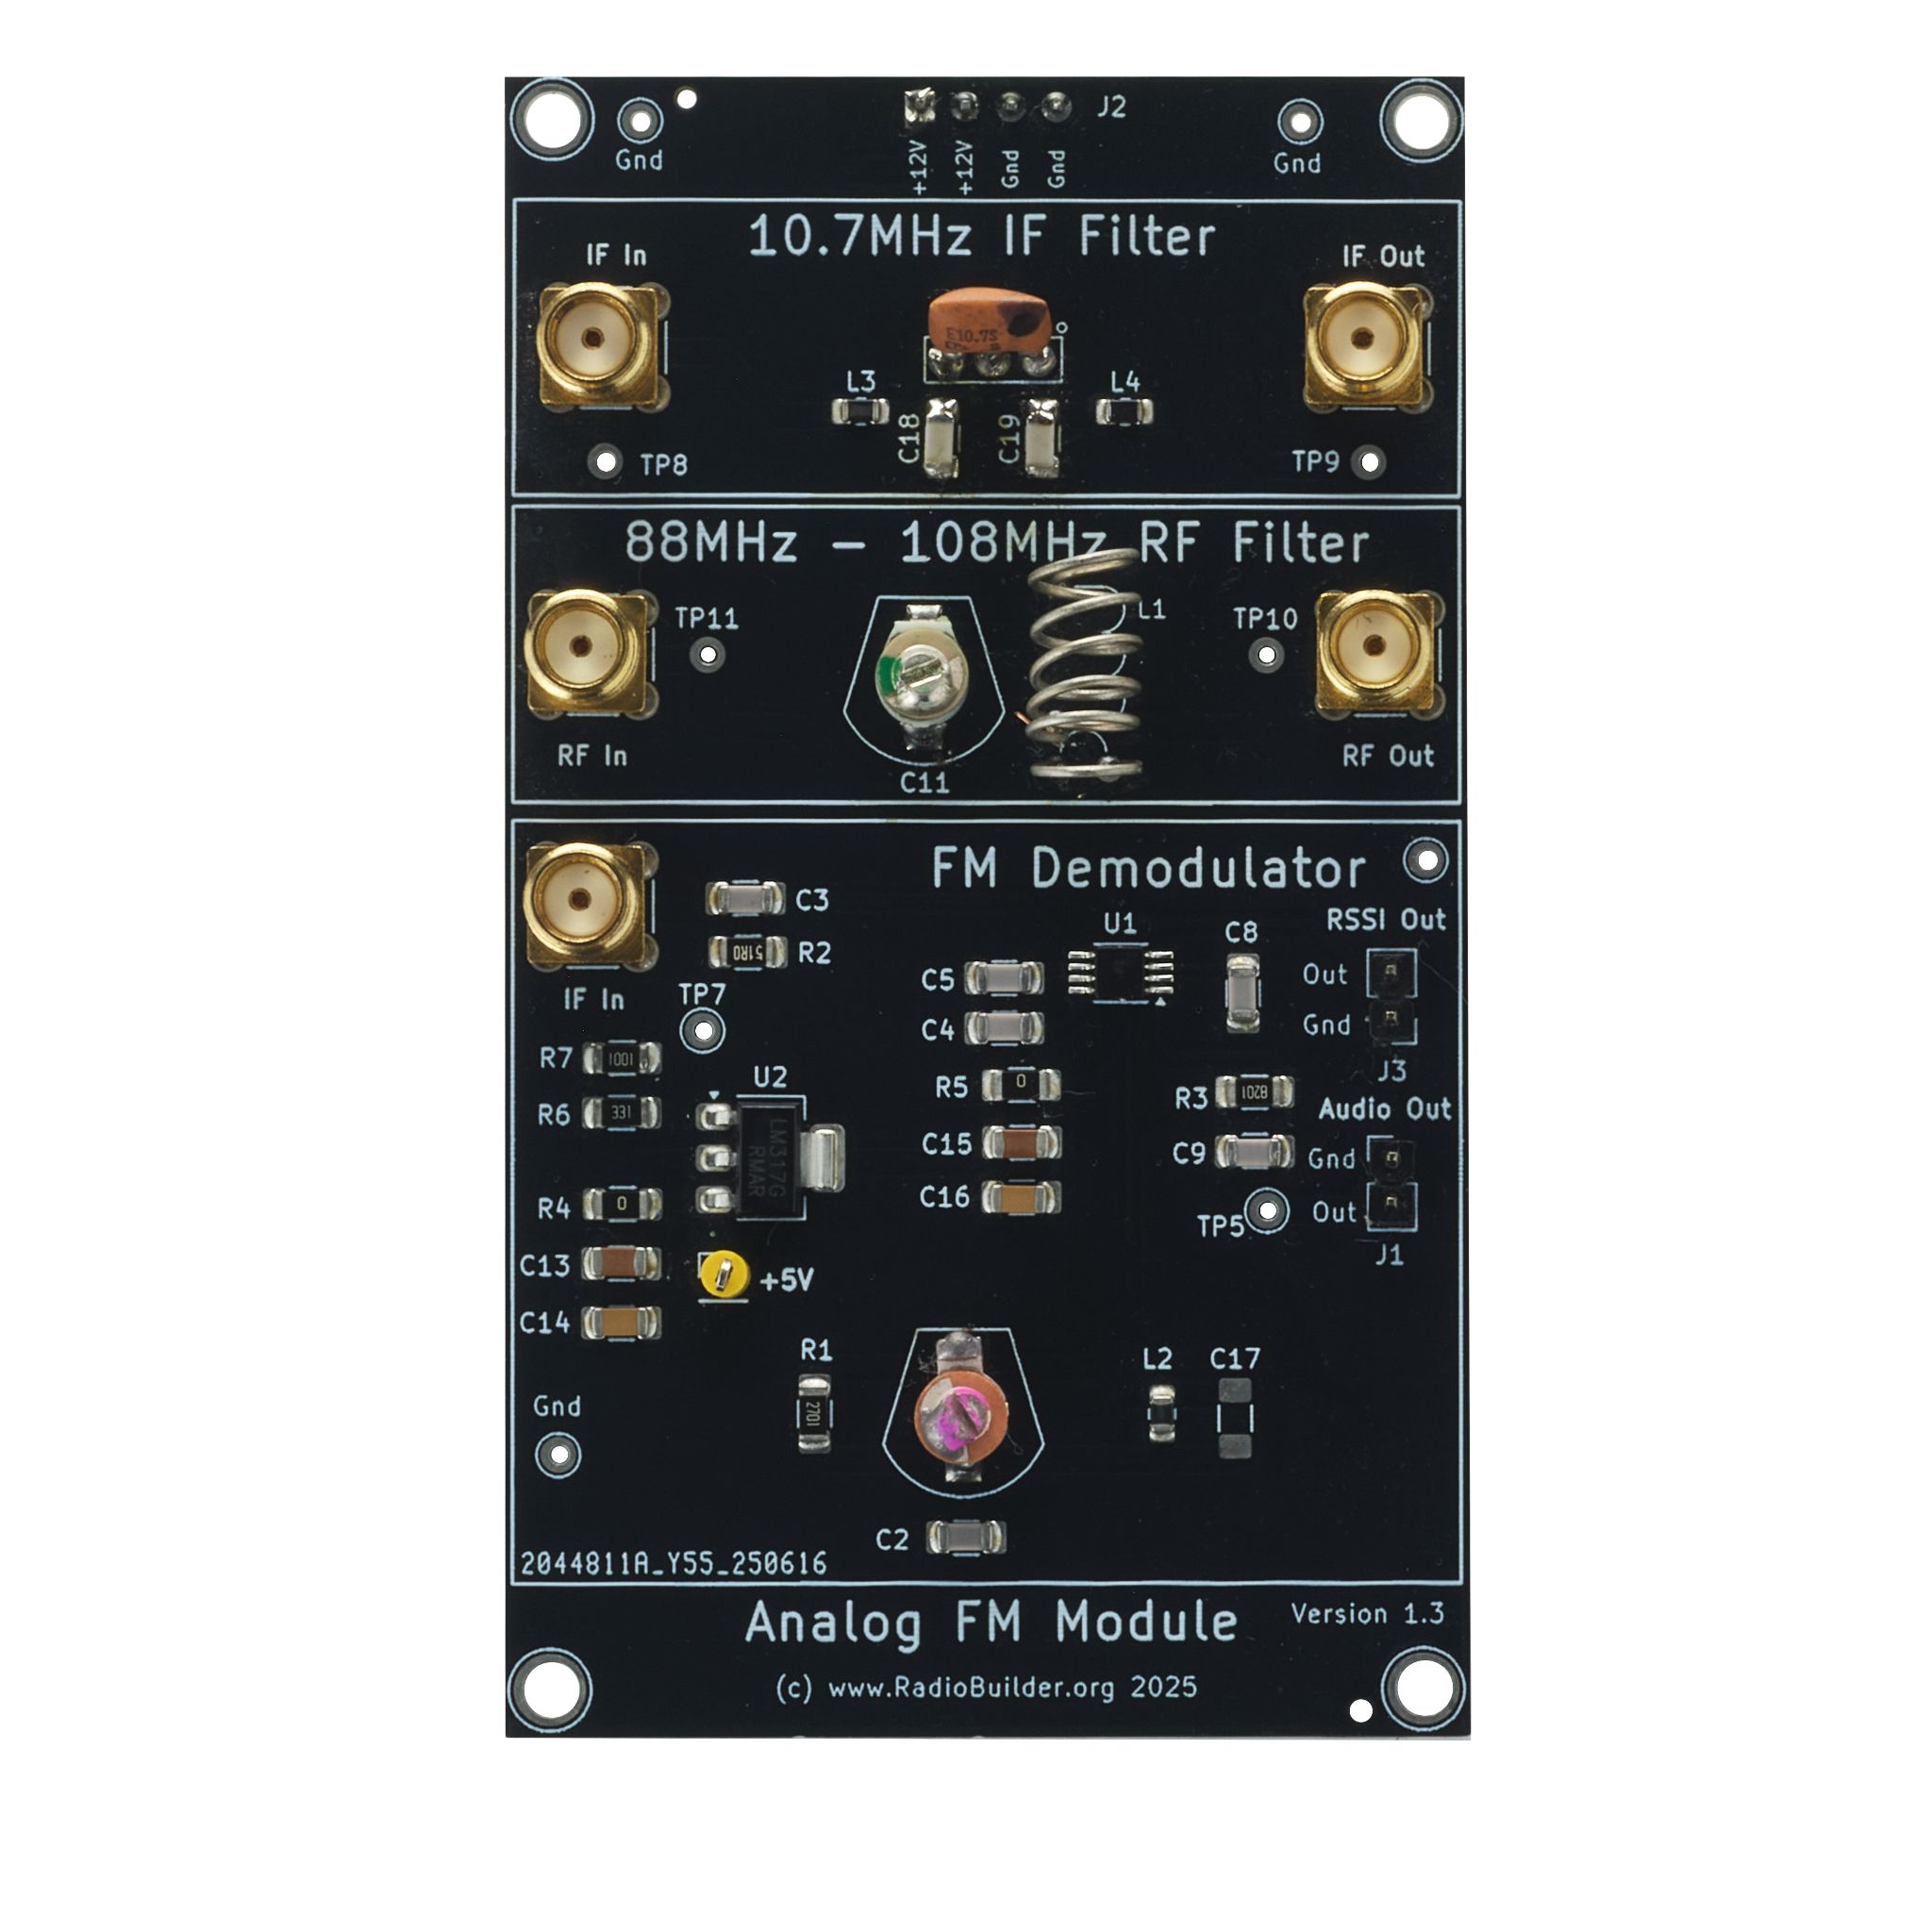
Component of the RadioLab
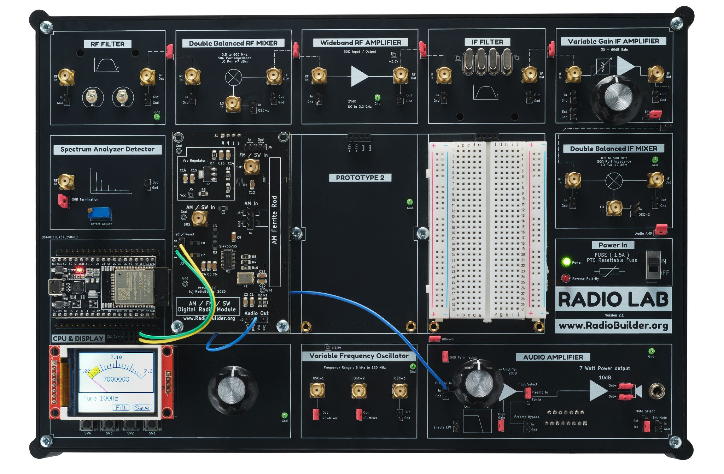

1.0 FM Broadcast Overview
Frequency Modulation (FM) broadcasting was developed in the 1930s by Edwin Armstrong as a solution to the noise and interference problems inherent in amplitude modulation (AM) radio. By encoding information in frequency variations rather than amplitude, FM provides significantly better immunity to electrical noise, improved audio fidelity, and greater dynamic range. FM broadcasting became widely adopted worldwide after the 1950s and remains in extensive use today for music, news, emergency broadcasting, and local radio services.
Despite the growth of digital radio and internet streaming, FM continues to be valued for its simplicity and reliability.

1.1 FM Broadcast Specifications
Parameter | Typical Value
RF band | 88 – 108 MHz
Channel spacing | 200 kHz
Modulation type | Wideband FM
Peak deviation | ±75 kHz
Audio bandwidth (mono) | 30 Hz – 15 kHz
Estimated RF bandwidth | ~180 kHz

1.2 FM Receiver Input Signal Levels (50 Ω Equivalent)
The table below shows typical RF input signal levels required for an FM broadcast receiver, referenced to a 50 Ω input impedance. These values indicate the approximate signal strength needed for different listening quality levels.
Condition | RF Level (dBm) | RF Voltage (approx, RMS)
Barely usable (noisy mono) | −105 to −100 dBm | 0.4 – 0.7 µV
Usable listening (quiet mono) | −95 to −90 dBm | 1 – 2 µV
Comfortable listening (good SNR) | −85 to −70 dBm | 4 – 25 µV
Strong local station | −60 to −40 dBm | 70 – 700 µV
Very strong / potential overload | > −30 dBm | > 2 mV

2.0 FM Broadcast Receiver Theory

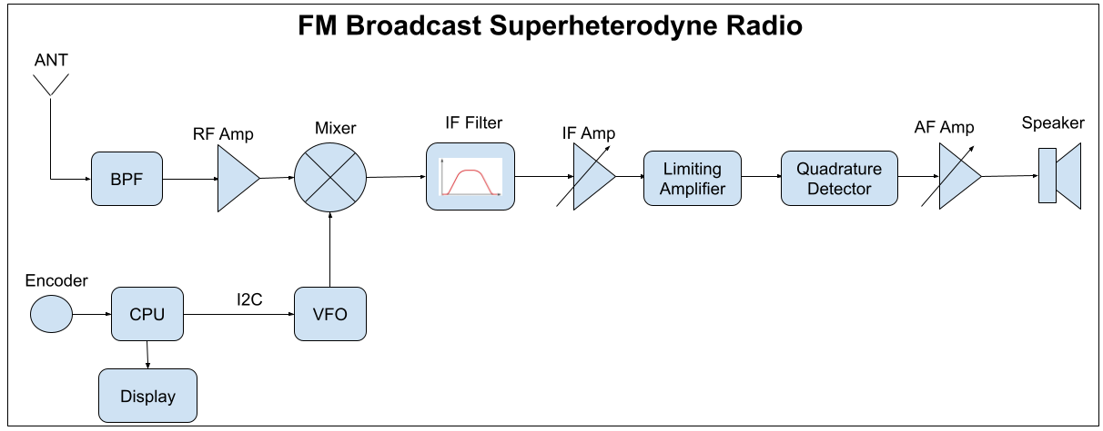
Block Diagram

2.1 Theory of Operation
The RadioLab FM Broadcast Receiver implements a classic superheterodyne architecture in which the incoming FM broadcast signal (88–108 MHz) is first band-limited by a tuned LC RF band-pass filter to provide initial selectivity and reject out-of-band interference.
The filtered RF signal is mixed with a tunable local oscillator (VFO) in a double-balanced mixer, translating the selected station down to a fixed intermediate frequency (IF) of approximately 10.7 MHz. The VFO can be tuned to 10.7MHz above or below the broadcast frequency of the desired station.
The IF signal is buffered and amplified, then passed through a ceramic 10.7 MHz IF filter and matching networks, providing channel selectivity (~180–200 kHz bandwidth) and additional rejection of adjacent channels and spurious responses.
A variable-gain IF amplifier allows the signal level to be optimised before demodulation.
The conditioned IF is then applied to the FM demodulator, where an internal IF amplifier drives a quadrature detector using an external tuned resonator to generate the required 90° phase shift; frequency deviations of the FM carrier are converted into a proportional baseband audio voltage.
The recovered audio is low-pass filtered and routed to the audio amplifier or external processing, while a derived RSSI output provides signal-strength information for optional monitoring or control.

2.2 Connection Diagram
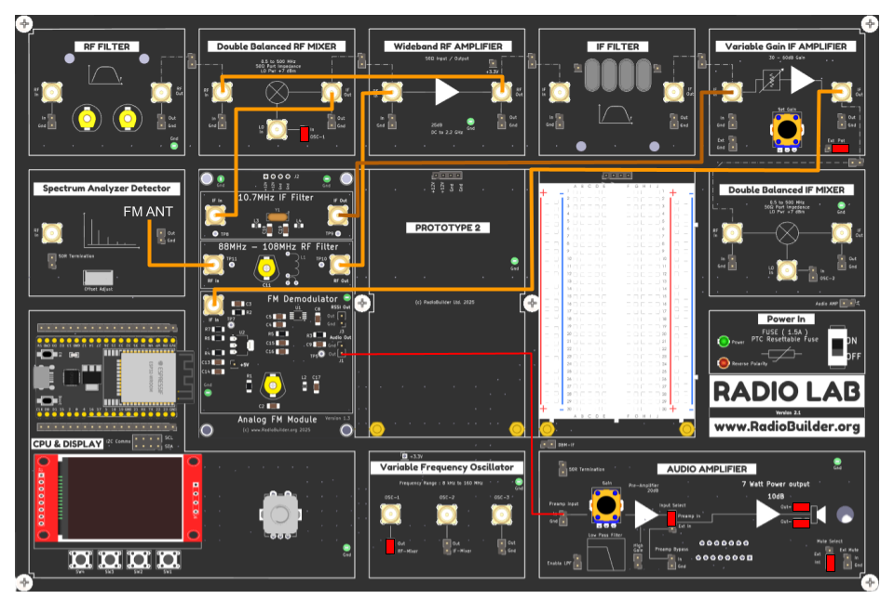
Connection Diagram

Note
On some systems it has been found that there is feedthrough from OSC-1 going to the RF Mixer into the RF Amplifier causing the amplifier to overload. If this happens use the IF Mixer and OCS-2 instead as this will eliminate this issue.

2.3 FM Antenna
For strong local stations a short wire of approx 30 inches long will work. However the impedance input of the RF Filter is suitable for a FM Dipole antenna. This antenna can be constructed with 50 Ohm coax cable and two lengths of wire as shown.

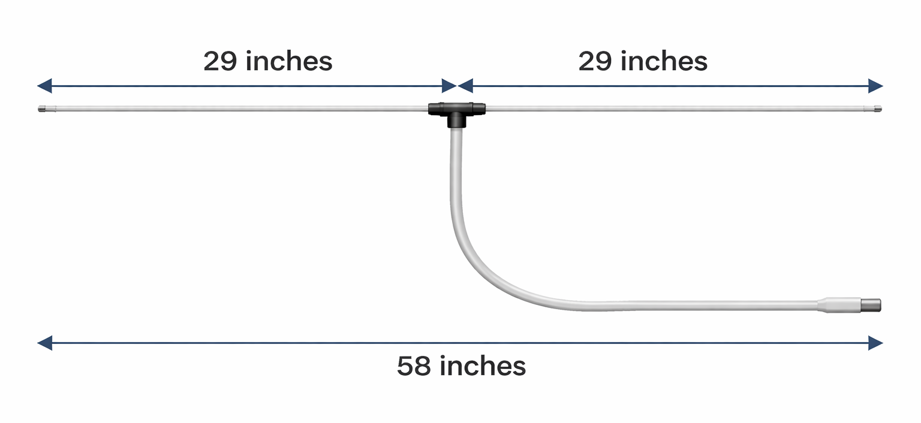

2.4 Operation

- Download the FM Radio sketch to the board
- Connect the FM Antenna
- Tune to a strong local station
- Adjust the RF Filter trimmer for maximum signal
- Adjust the demodulator for maximum audio clarity

2.5 Example connections using IF Mixer
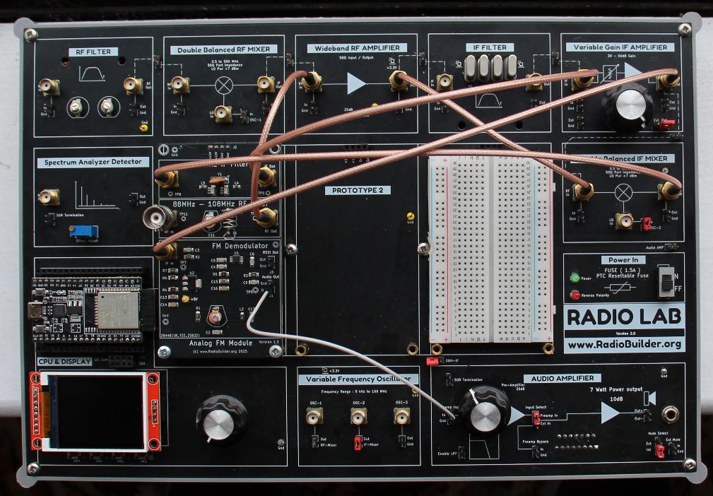

3.0 Schematic Diagram
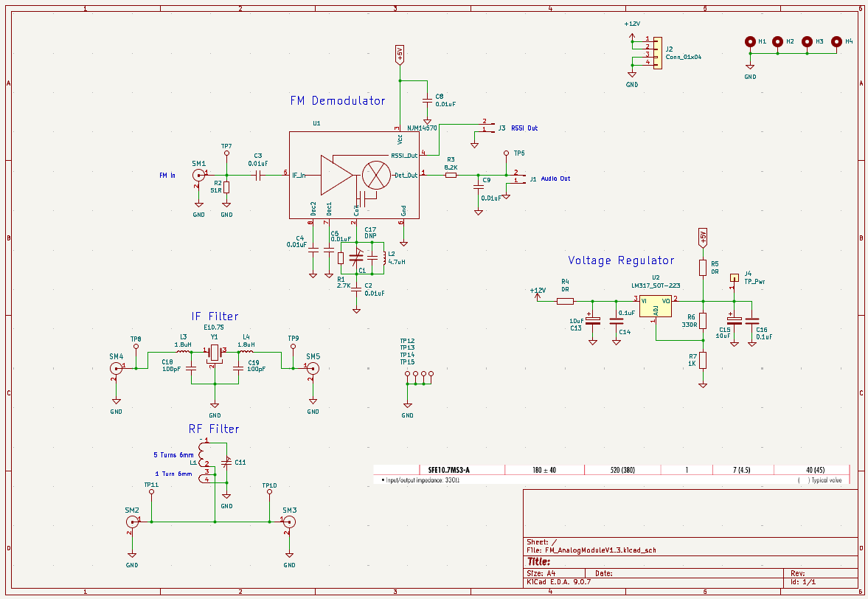
Broadcast FM Receiver Module Schematic

4.0 Circuit Description

4.1 Radio Frequency (RF) Filter Design

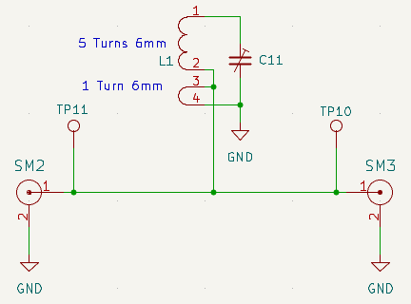

The circuit is a simple tuned LC band-pass formed by inductor L1 and variable capacitor C11. L1 is a tapped air-core coil (5 turns + 1 turn, 6 mm diameter) and C11 trims the resonant frequency.
At resonance, the LC network selects a narrow frequency region. Adjust C11 to shift the center frequency as required. This stage is used for RF frequency selection and interference rejection ahead of subsequent RF circuitry.

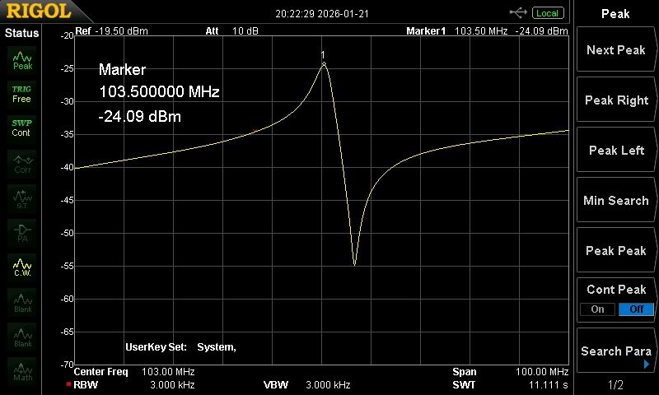
RF filter frequency response

4.2 Intermediate Frequency (IF) Filter Design
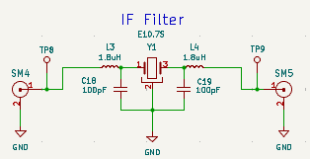

4.2.1 Ceramic Filter Y1

The IF Filter part number SME10.7MS3-A is a 3-pin ceramic IF filter with a
- 10.7 MHz center frequency (±30 kHz tolerance)
- 180 ± 40 kHz 3 dB bandwidth
- 520 kHz max 20 dB bandwidth
- ≤1 dB ripple
- ≤7 dB insertion loss (≈4.5 dB typical)
- ≥40 dB spurious attenuation (9–12 MHz)
- 330 Ω nominal input/output impedance

4.2.2 Matching Networks

A pair of matching networks convert the 330 Ohm input / output impedance of the filter to 50 Ohm.
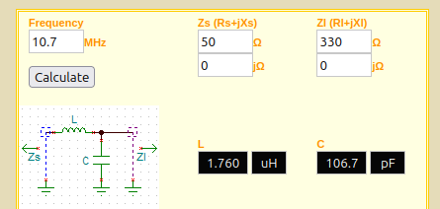
https://leleivre.com/rf_lcmatch.html

Closest standard values are 1.8uH and 100pF.

4.2.2 IF Filter frequency response

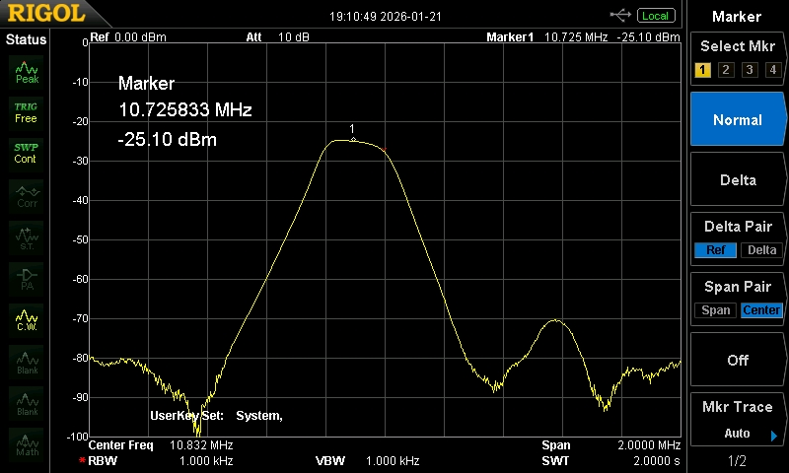
Measured IF filter frequency response

Measured center frequency 10.726 MHz.
3 dB bandwidth ~200 kHz
Insertion loss –20 − (–25.1) = 5.1 dB

4.2.3 Ceramic Filter Specifications

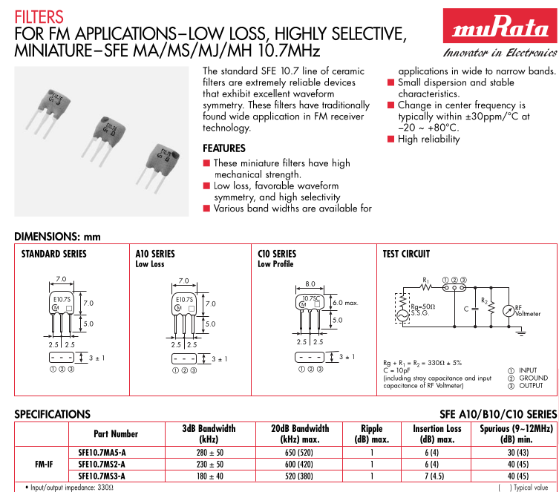

4.3 Carson’s Rule and FM Broadcast Bandwidth
The occupied bandwidth of a frequency-modulated (FM) signal can be estimated using Carson’s Rule:
Bandwidth ≈ 2 × (Deviation + Modulating Frequency) BW ≈ 2 × (Δf + fm)
Where:
- Δf = Peak frequency deviation (Hz)
- fm = Highest modulating frequency (Hz)
FM Broadcast (±75 kHz Deviation)
Peak deviation Δf = 75 kHz
Maximum audio frequency fm = 15 kHz
Calculation:
BW = 2 × (75 kHz + 15 kHz)
BW = 2 × 90 kHz
BW = 180 kHz
So a broadcast FM signal with ±75 kHz deviation occupies approximately 180 kHz of RF bandwidth.
This matches typical FM channel spacing (~200 kHz) and common IF filter bandwidths.

4.4 FM Demodulator Design

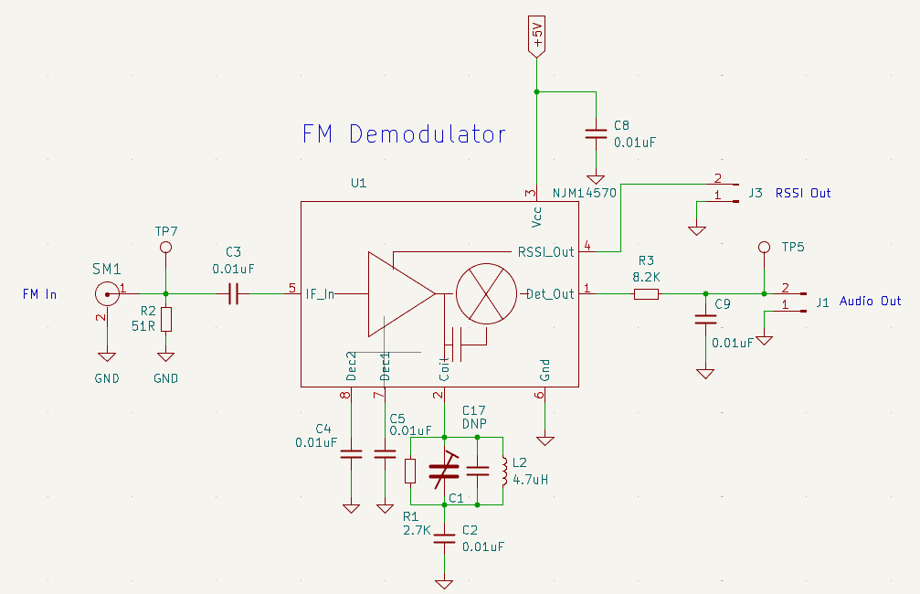

This stage performs FM demodulation of the intermediate-frequency (IF) signal and recovers the baseband audio.
The IF signal from the previous RF/IF stages enters at SM1 (FM In) and is impedance-matched by R2 (51 Ω). The signal is AC-coupled via C3 into the NJM4570 FM demodulator IC (U1).
Inside U1, the IF amplifier drives a quadrature detector. The external tuned network (L2, C1, C2, R1) connected to the Coil pin forms the quadrature resonator, tuned to the IF center frequency. This network provides a 90° phase-shifted reference needed to convert frequency variations of the FM signal into a proportional voltage (audio).
The recovered audio appears at Det_Out, filtered by R3 / C9 to remove residual IF and noise, and is available at J1 (Audio Out).
An internal limiter and detector also generate a received signal strength indication at RSSI_Out, routed to J3 for signal level monitoring or squelch control.
C8, C4, C5 provide supply and internal node decoupling for stable operation.
In an FM broadcast receiver, this block converts the selected IF signal into baseband audio and signal strength information, completing the RF → IF → audio signal chain.

4.4.1 Quadrature Detector – Theory of Operation Overview

A quadrature detector is used to convert a frequency-modulated (FM) signal into a voltage that represents the original audio signal.
The incoming IF signal (typically 10.7 MHz) is split into two paths. One path goes directly to a multiplier or phase detector. The second path passes through a tuned LC network that shifts the signal phase by approximately 90 degrees at the centre frequency. Because this network is frequency-dependent, any change in frequency causes the phase shift to move slightly above or below 90 degrees.
When the two signals are multiplied (or phase-compared), the phase difference between them is converted into a voltage. At the centre frequency the phase difference is exactly 90 degrees and the output voltage is near zero. When the frequency increases, the phase shift becomes slightly greater than 90 degrees and the output voltage moves positive. When the frequency decreases, the phase shift becomes slightly less than 90 degrees and the output voltage moves negative.
The result is a voltage that is proportional to the instantaneous frequency deviation of the FM signal. This voltage is the recovered audio signal. A low-pass filter removes any remaining RF or IF components, leaving clean baseband audio.
Quadrature Detector – Theory of Operation (Mathematical)
Let the incoming IF signal be:
v1(t) = A cos(2π f t)
where
A = signal amplitude
f = instantaneous frequency of the FM signal
The signal is split into two paths.

Path 1 – Direct Signal
v1(t) = A cos(2π f t)

Path 2 – Quadrature Network
The tuned LC network introduces a frequency-dependent phase shift φ(f):
v2(t) = A cos(2π f t + φ(f))
At the IF centre frequency f0 (for example 10.7 MHz):
φ(f0) ≈ 90° = π/2 radians
Near f0 the phase varies approximately linearly with frequency:
φ(f) ≈ π/2 + k (f − f0)

where
k = slope of phase versus frequency (rad/Hz)
Phase Detector / Multiplier
The two signals are multiplied:
vout(t) = v1(t) × v2(t)
vout(t) = A² cos(2π f t) cos(2π f t + φ)
Using the identity:
cos(x) cos(y) = 0.5 [ cos(x − y) + cos(x + y) ]
So:
vout(t) = (A² / 2) [ cos(φ) + cos(4π f t + φ) ]
After low-pass filtering, the high-frequency term is removed, leaving:
Vout_DC = (A² / 2) cos(φ)

Relationship to Frequency Deviation
Substitute φ(f):
Vout ≈ (A² / 2) cos( π/2 + k (f − f0) )
Using:
cos(π/2 + x) ≈ −x (for small x)
Therefore:
Vout ≈ − (A² / 2) k (f − f0)
This shows that the output voltage is approximately proportional to the frequency deviation:

Vout ∝ (f − f0)

Since the FM signal varies its frequency according to the audio modulation, the output voltage reproduces the original audio waveform.

4.4.2 NJM14570 Datasheet 1st Page
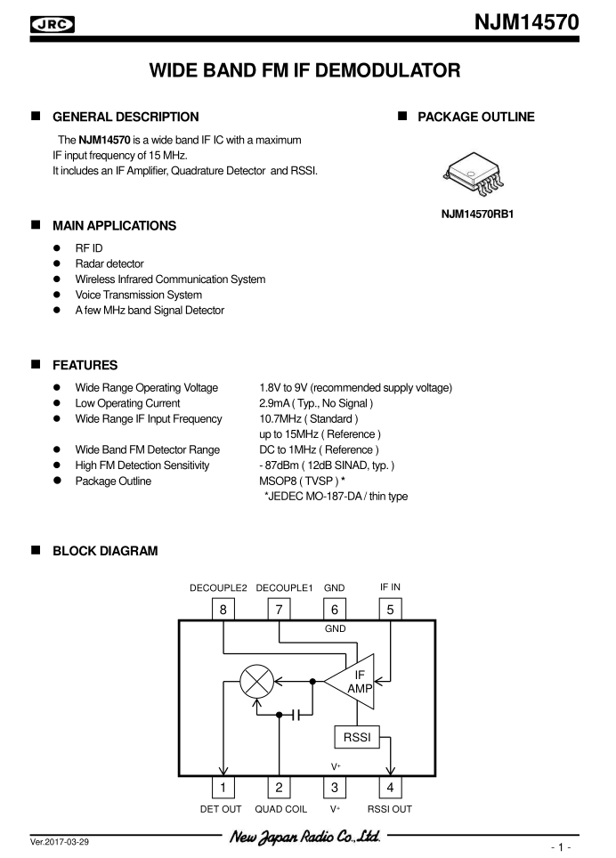

5.0 Embedded Software
In its simplest form the software only needs to set OSC-1 to 10.7MHz above or below the broadcast frequency of the desired station.

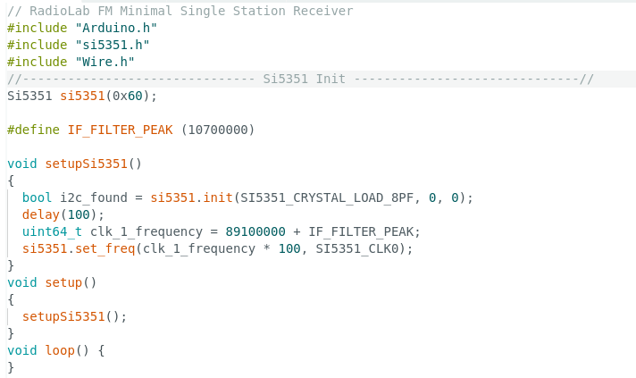

6.0 Signal Tracking

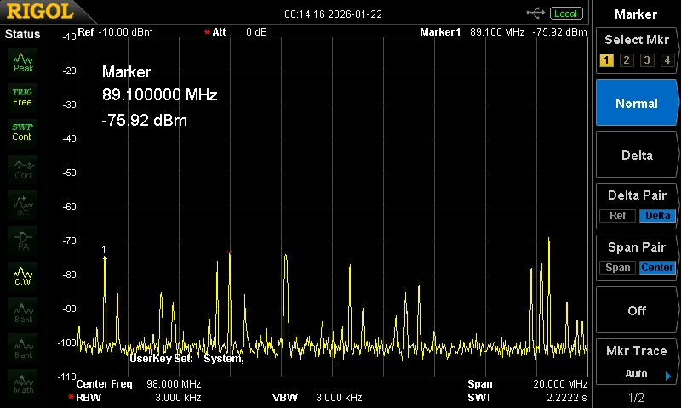
FM Broadcast Spectrum

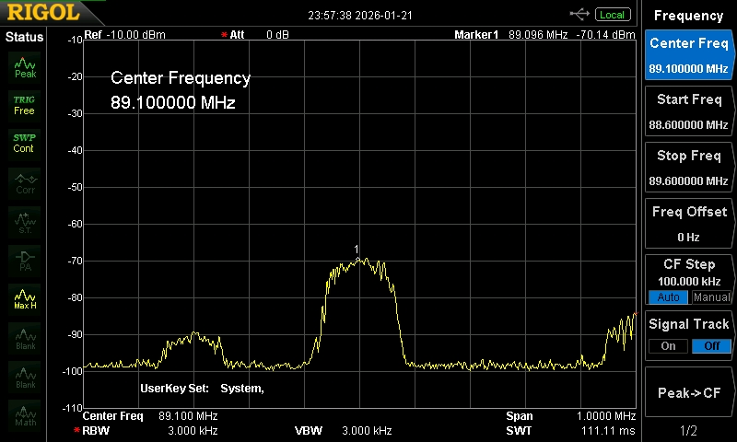
Zoomed in on 89.1MHz Station
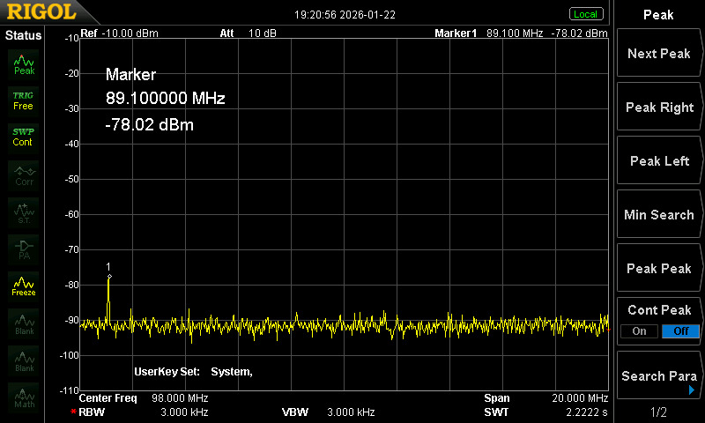
RF Filter Output

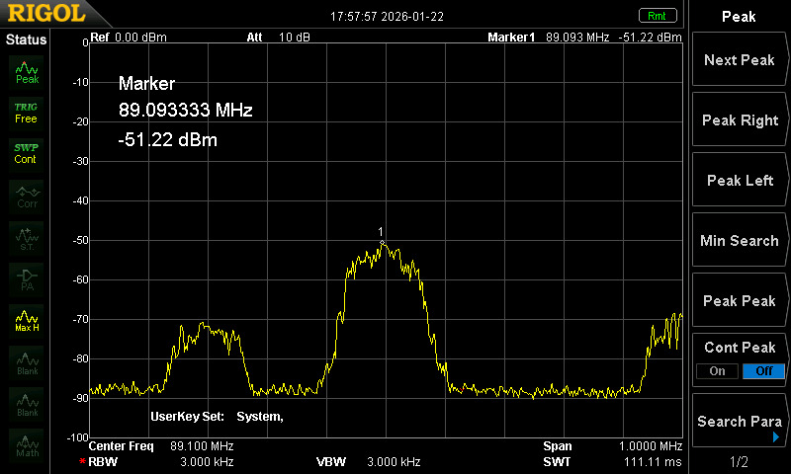
RF Amplifier Output

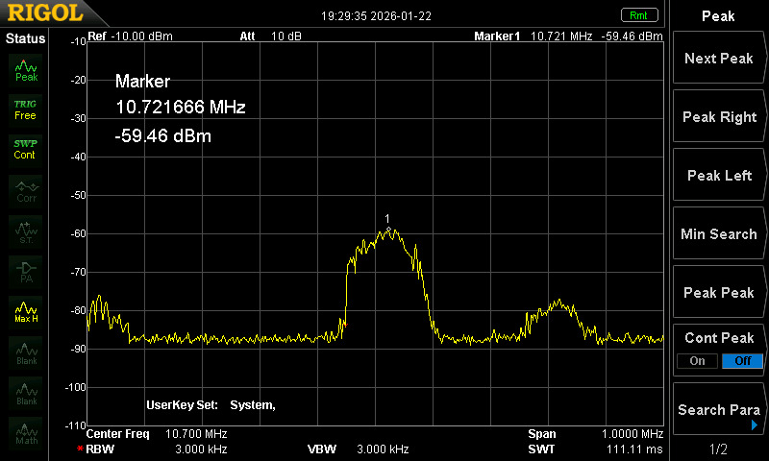
Mixer Output

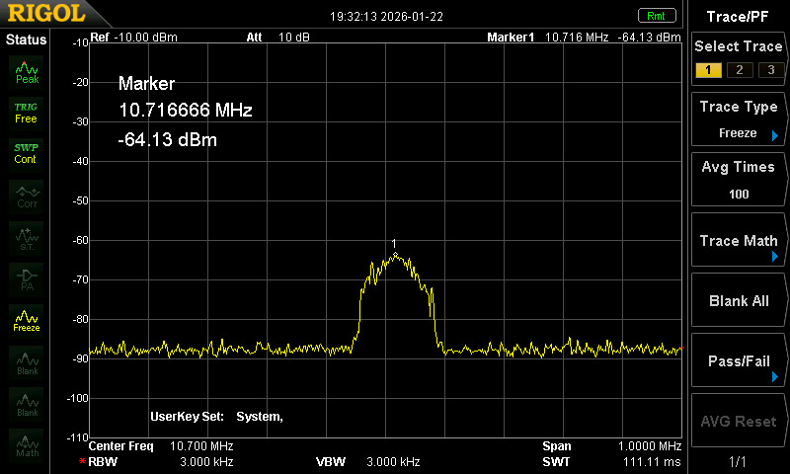
IF Filter Output

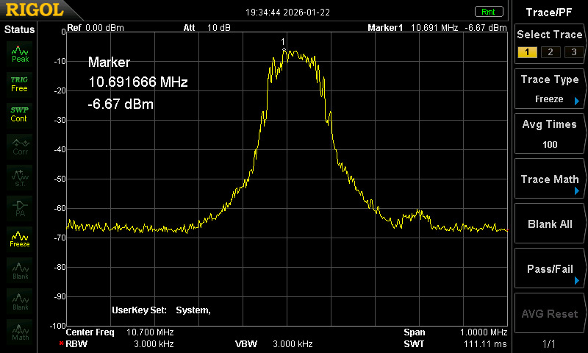
IF Amplifier Output

5.0 Assembly

The following is the kit of parts for the FM Broadcast Receiver Module.

Part | Qty
Y1 SFE10.7MS3-A | 1
4 Pin Header | 1
LF Trimmer | 1
HF Trimmer | 1
Solid Wire 150mm | 1
FM Broadcast PCB | 1

5.1 Step 1 - FM Demodulator
Insert and solder the LF Trimmer. Note the color of the trimmer!

5.2 Step 2 - RF Filter
Insert and solder the HF Trimmer. Note the color of the trimmer!

Use solid wire to create 5 turns on 6mm diameter for top part of L1

Use solid wire to create 1 turn on 6mm diameter for the bottom part of L1.

5.3 Step 3 - IF Filter
Insert and solder filter into Y1

5.4 Step 4 - Header Connector

Insert and solder the 4 pin header on the underside of the board in J2.

5.5 Step 4 - Complete Assembly

